Game Graphics in 8-Bit Assembly

This document is a compilation of my notes from the ‘Let's Make EdVenture’ Youtube course by ‘Mission: Ed Possible’. Per the playlist description, this course is a tutorial series for making a Rogue-like style game in Atari 8-bit 6502 Assembly Language. A big thanks to Ed for creating this incredibly informative playlist!

<https://youtube.com/playlist?list=PL7IgmhqRiwzFrYkkmF2PuxODsAVTSYeZL&si=8MdvZD9ku17IfydM>

Writing a Text Character to the Screen



Writing a String of Text Characters to the Screen



Atari Antic Graphics Modes

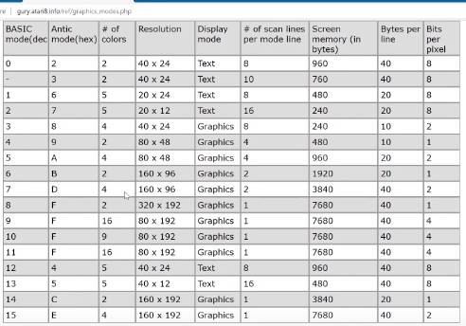

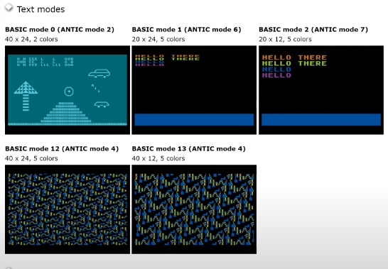

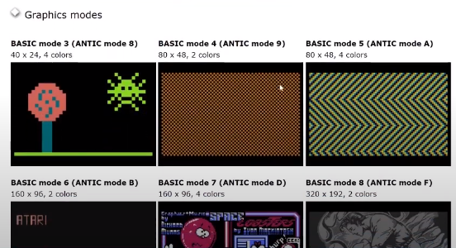

Writing Characters using Antic Mode Graphics

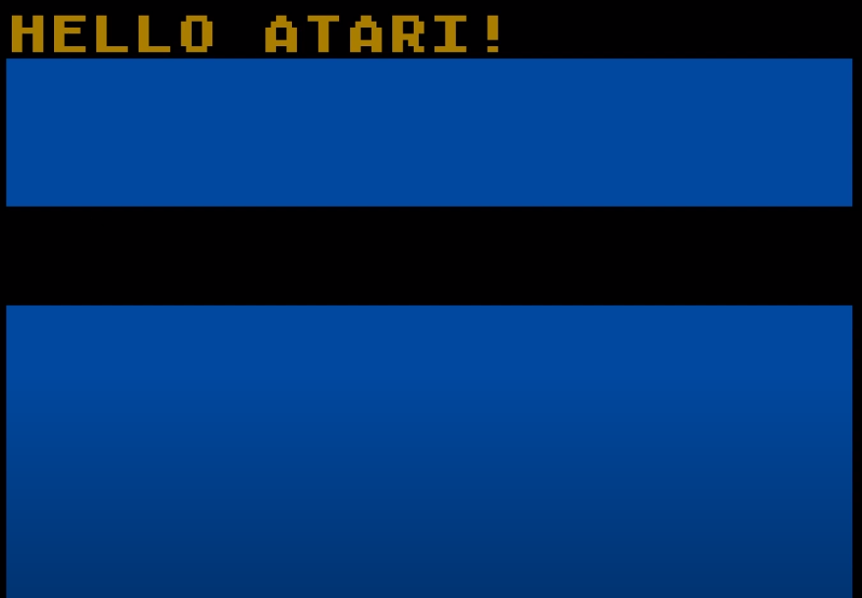

Painting a Single Bit (Top Right) in an 8x8 Tile

* Antic 2 for the Top Line, Antic 5 for the Remaining Lines
* Screen is 40 x 12? (320x96 = 30,720 bits, 160x192 = 30,720 per Wikipedia)

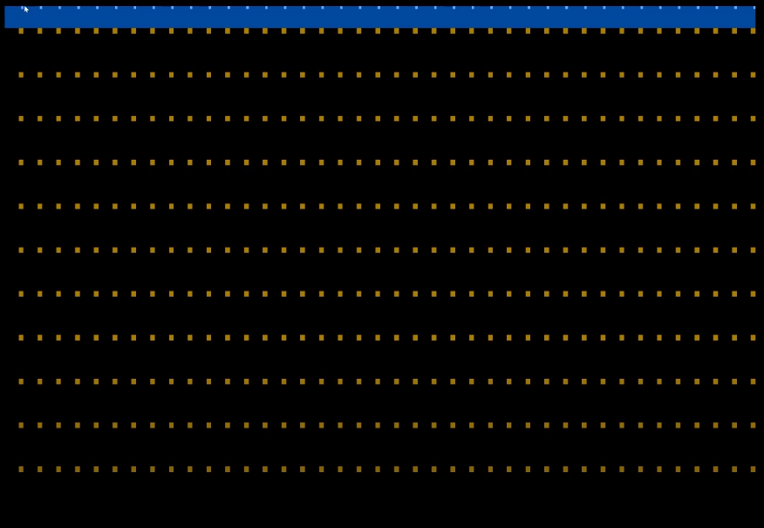

Painting a Slash by Painting Individual Bits

* Antic 2 for the Top Line, Antic 5 for the Remaining Lines

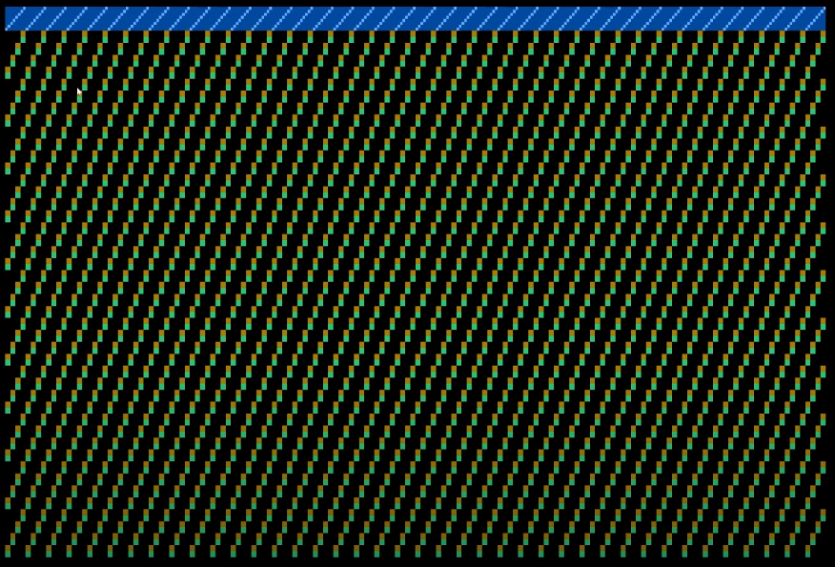

Painting an ‘X’ by Painting Bits

* Antic 2 for the Top Line, Antic 5 for the Remaining Lines

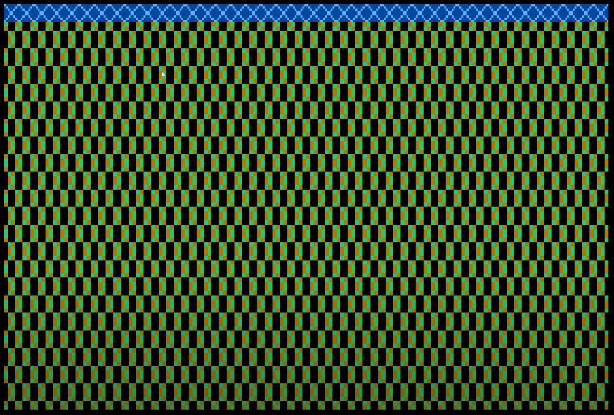

Illustrating Character Width and Demonstrating How We Can Create Patterns

* Antic 2 for the Top Line, Antic 5 for the Remaining Lines

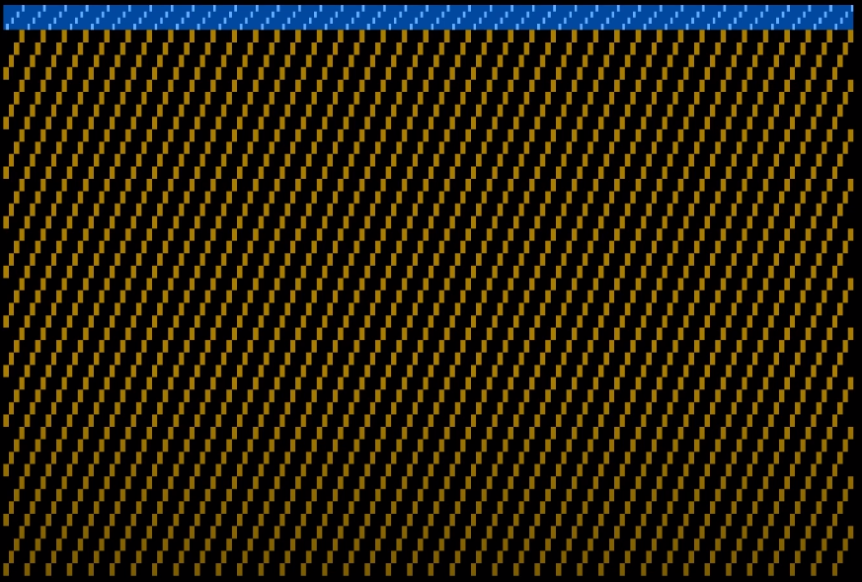

* Antic 2 for the Top Line, Antic 5 for the Remaining Lines

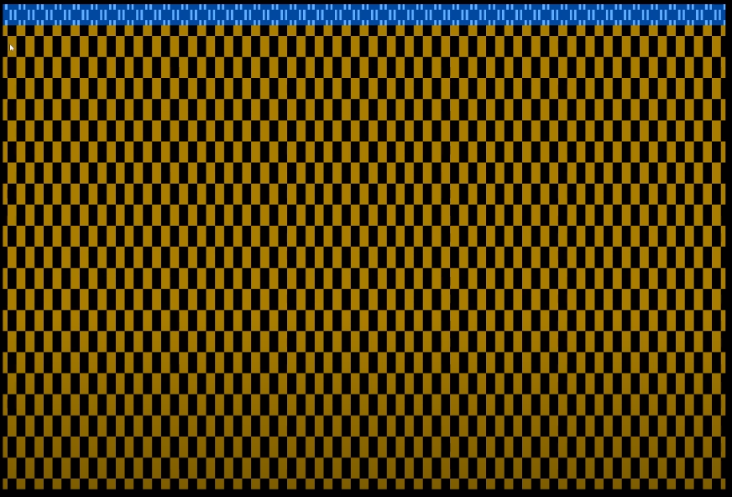

Working towards Creating a Ball

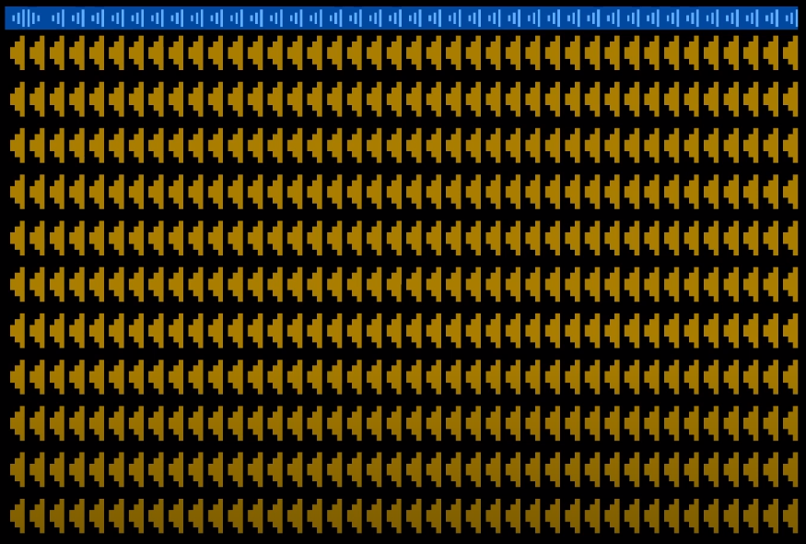

Painting the Ball Using Multiple Colors

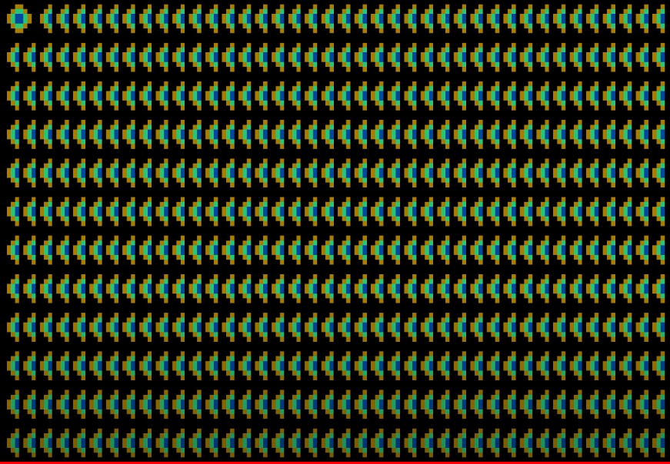

ASCII Character Set

- Rather than painting individual bits to draw to the screen, we can call upon pre-configured characters from memory. This is the ASCII Table as configured from the Atari (ATASCII).

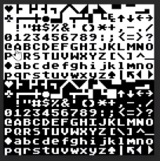

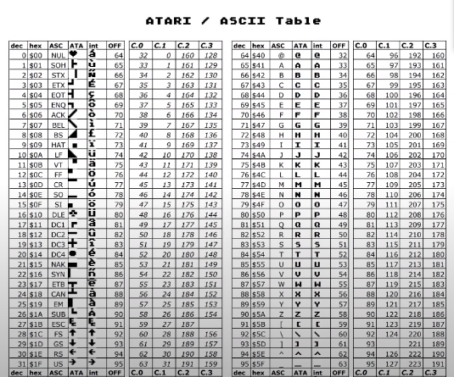

NTSC Palette

* This tale allows colors to be called upon via a hex code. Ex. A0 is light grey.

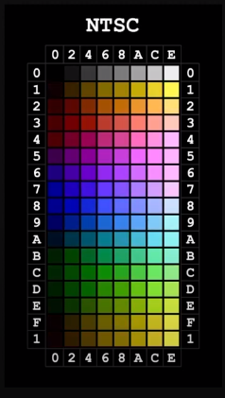

Using Color Tables to Paint Two Separate Colored Balls

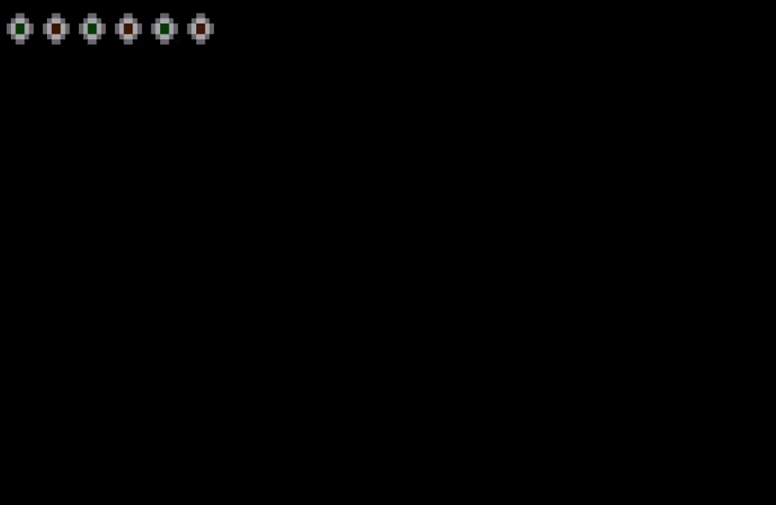

Using PhotoShop to Create Model Graphics

* Single “Wall Tile” Drawn in an 8x8 Grid. The pattern is drawn with the intention of repeating it to create an intricate design

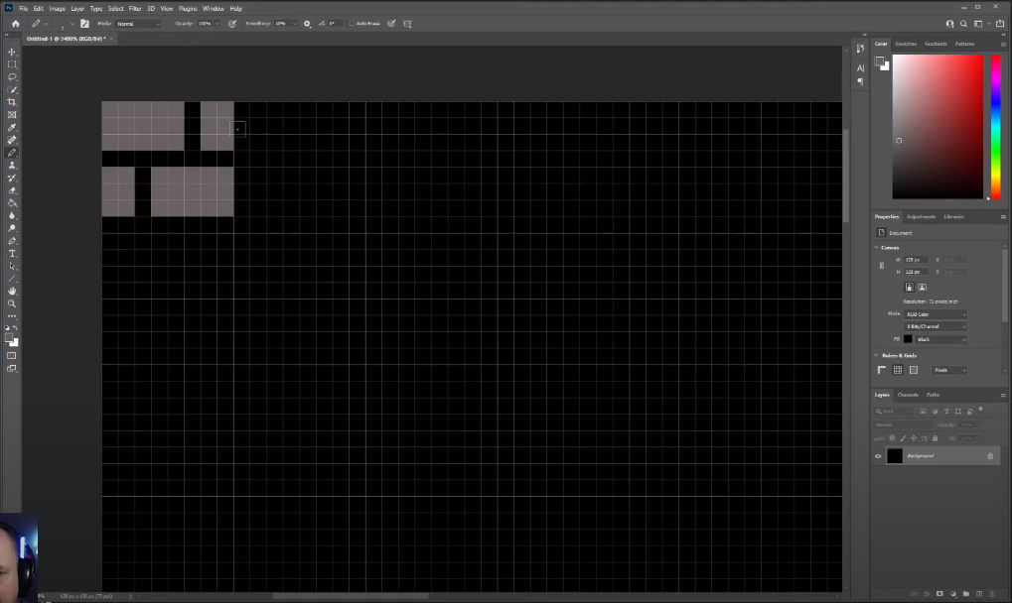

Writing the Code for a Single Tile of the Tile as Drawn in PhotoShop. Multiple colors are used to add dimension, a lighting illusion, and visual interest.

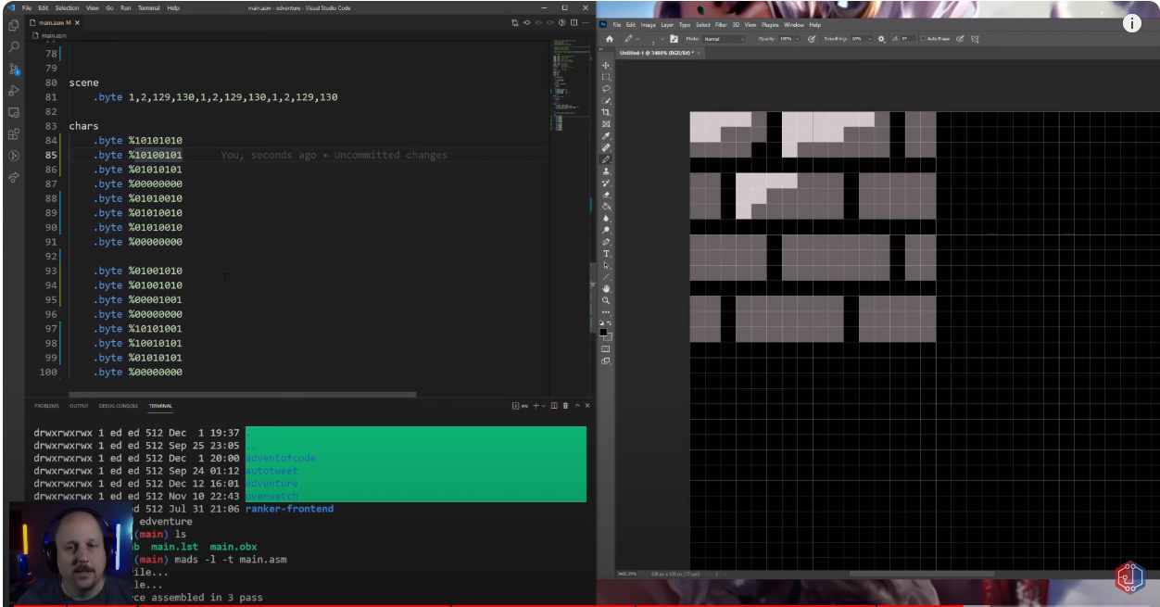

Running the Code



Creating More Model Graphics in PhotoShop

* To create a game map, we create a Wall Tile, a Floor Tile, a Door Tile, and up/down stairs tiles

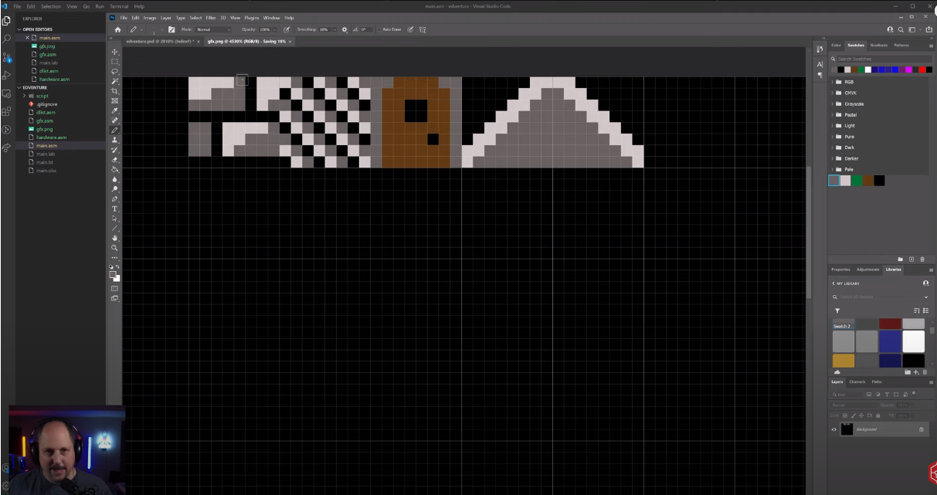

Write Assembly Code to Methodically Place the Individual Tiles to Create a Game Map

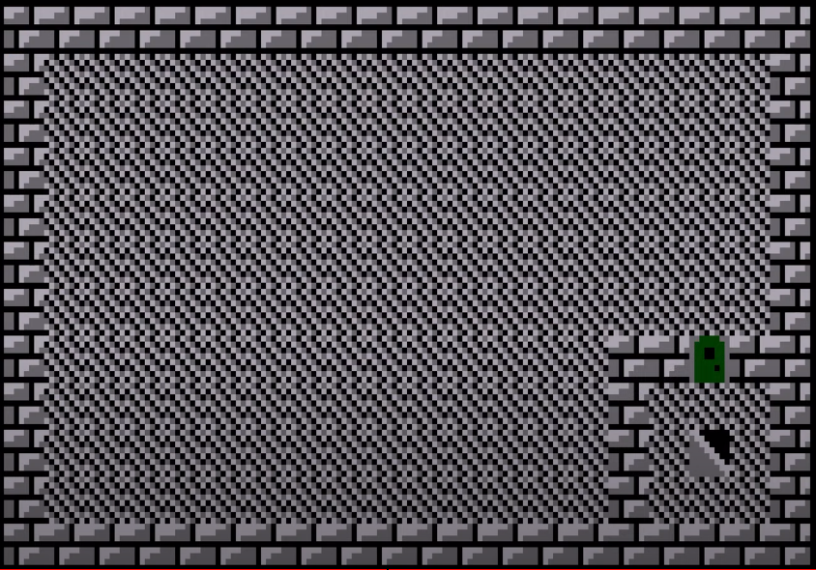

Use PhotoShop to Create a Model Player Character

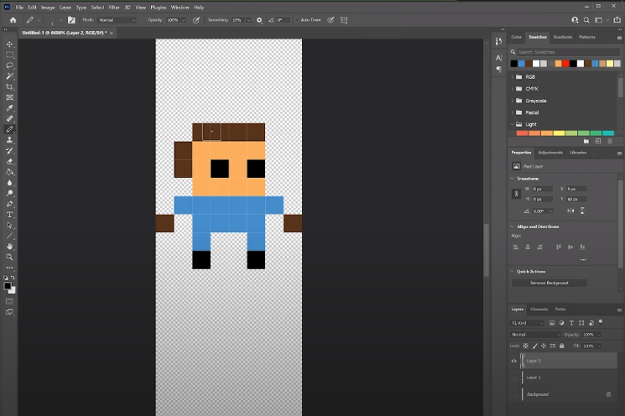

Use Player Missile Graphics (PMG) to Add More Colors and Overlay Player On Top of Map

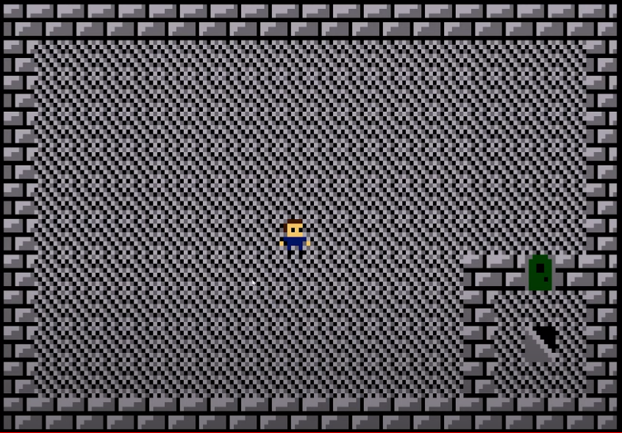

Note that up to this point, we’ve been using ‘Characters’ and Painting Individual Bits to create graphics. We’re going to change this approach and start using ‘Tiles’ that we create for the purpose easy re-use.

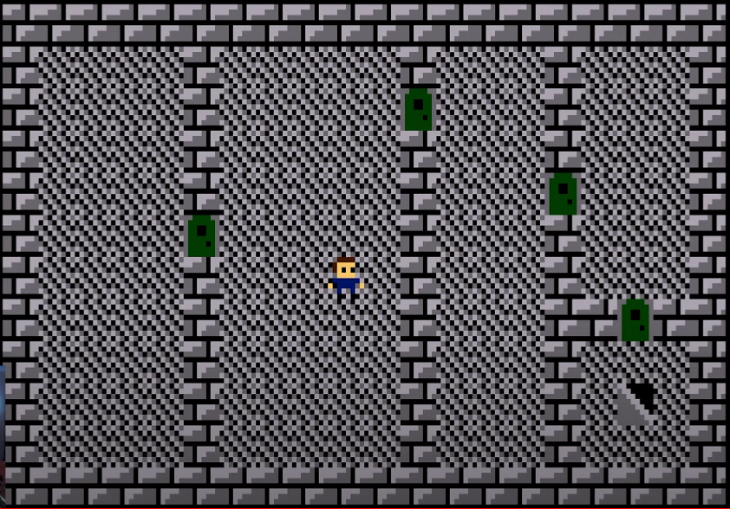

Expand the Map for longer Gameplay and Add Interest Elements (hallways, etc.)

Add the Ability for the Playfield to Move so the entire Map doesnt need to Fit onto the Screen

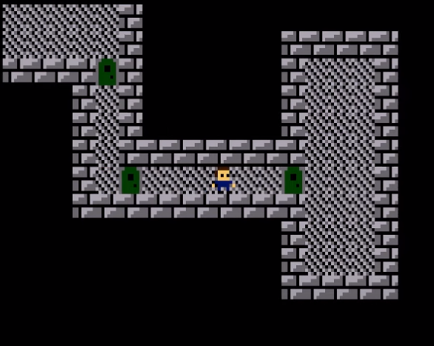

Add Collision Detection to keep Player within the walls

Add “Line of Sight” So the Player can only see things he is relatively close to

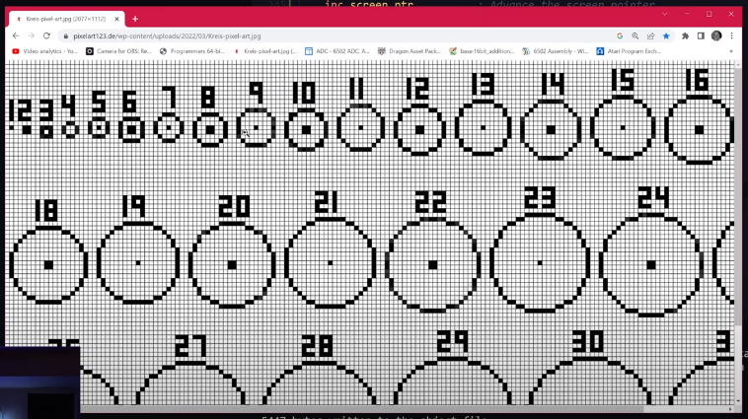

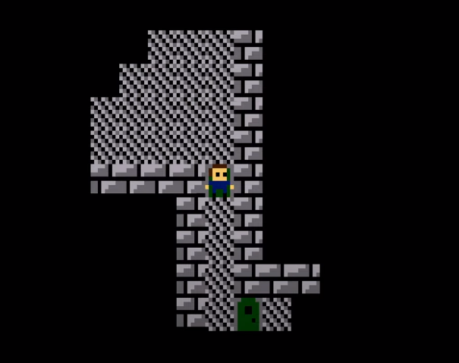

Create a Story Line / Create Graphic Elements Associated with the Story Line

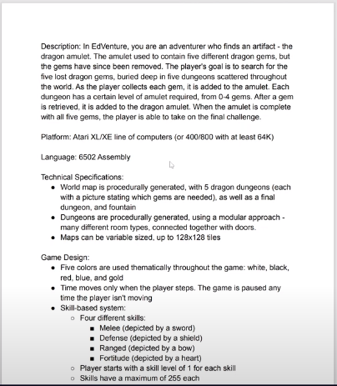 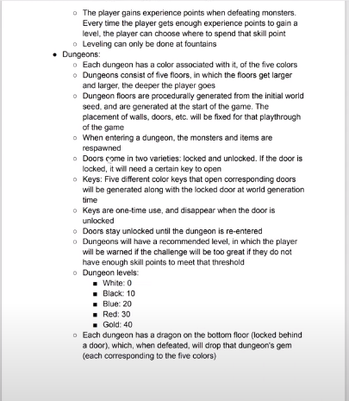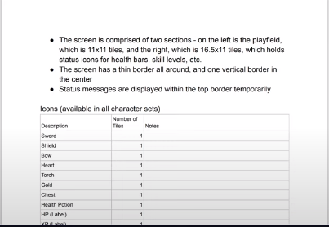

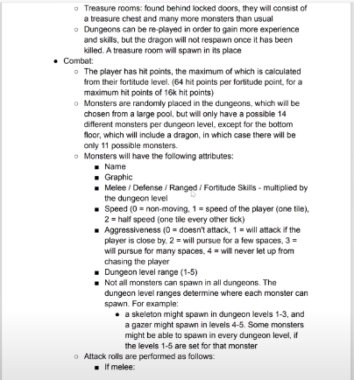

* Draw Graphic Elements in Photoshop to get the Art looking as intended, then port the graphic over to the Assembly Code as we did above with the Walls, Door, Stairs

Dungeon Outdoor

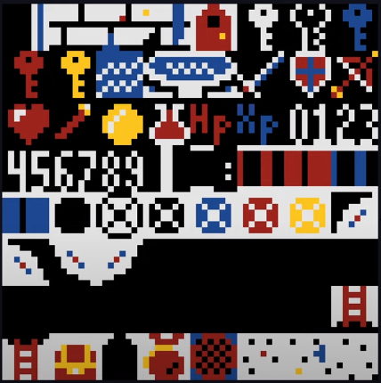 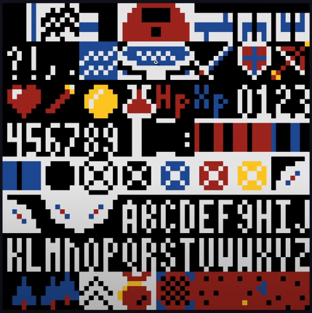

Monsters

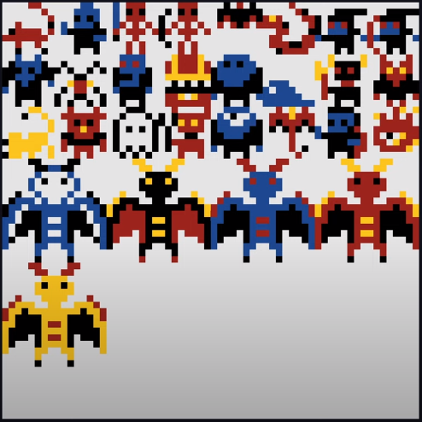

* Collision Detection Modified from simply being able to detect walls, to now being able to detect the rest of the graphics elements
  + Elements 56 (down ladder) and up are “walk through” elements. Elements 1 - 55 cannot be “walked through”. Reminder, graphics tiles are 8x8 (64 total).
* Create a separate file called “Labels”, where these graphics elements (aka Tile 56 is assigned the “Ladder” label. This makes calling on these graphics much easier in the game logic code.

Shift The Playfield, so that half of the screen is dedicated to the playfield and half of the screen is dedicated to a Status Dashboard

* Decluttered the Floor Tile, Swapped Stairs for Ladders, Modified some graphics colors to maximize visual appeal / contrast while keeping within our graphics memory constraints (swapped out light and med grey for just grey and white. Swapped red brown for brown. Swapped out Green for Blue to include water elements).

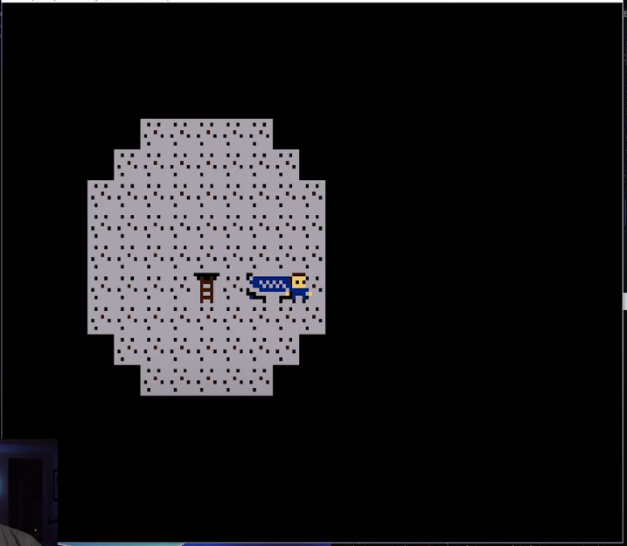

Add Borders for the Status Dashboard

* Since we’re finally at a point where we are starting to write game logic, we need restructure our code so the screen is not writing at all times. We need a period of time where the screen writes, and the game logic can be performed in between screen writes (or while the screen counter is in the “porch” section of the screen, using V-sync/H-sync).
  + This is our first implementation of a Data Stack in the Game Code
* Borders are generated one tile at a time, like the rest of the graphics (N, S, E, W border)

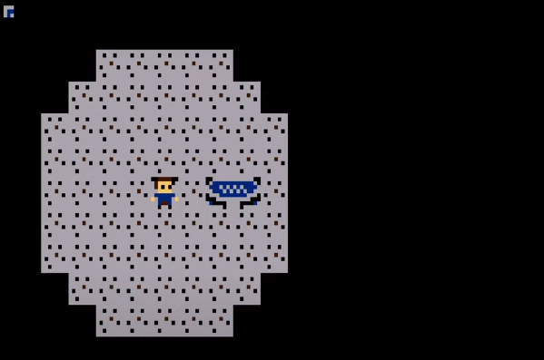

* Until now a fixed delay was used to slow down the rate at which the player moved across the playfield. When game logic was added, this fixed delay caused timing problems and glitches. Restructure the delay so it’s not a fixed value.
* Add the ability to blit just a character to the screen, so that we only write the game dashboard once, and we only update the status characters when a change occurs.

Fun Note - If you have a bug in your collision detection and your player is able to leave the playfield, you can expect to vidually see the graphics saved in the graphics memory addresses. Your player is traversing memory locations at this point and you see whatever is stored in those addresses.

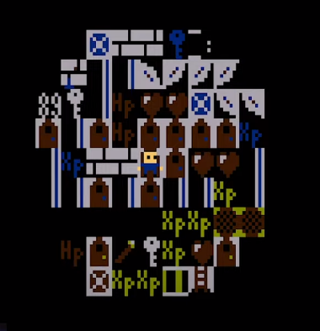 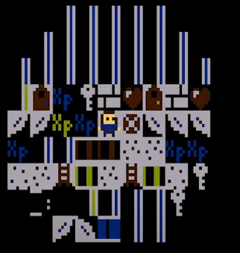 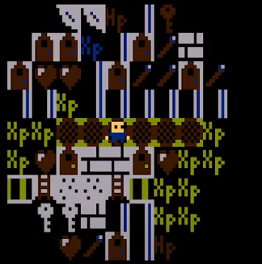

Complete Border

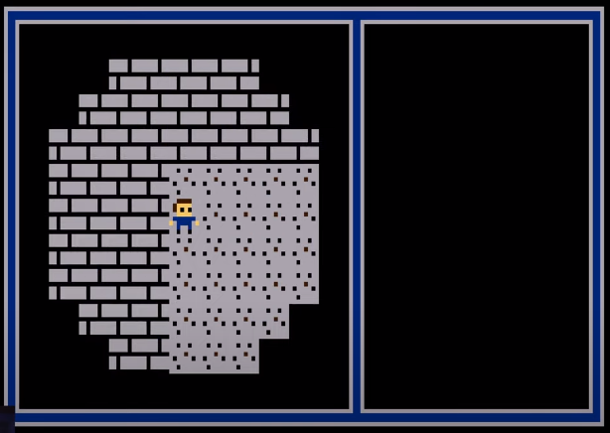

Add UI / Status Dashboard

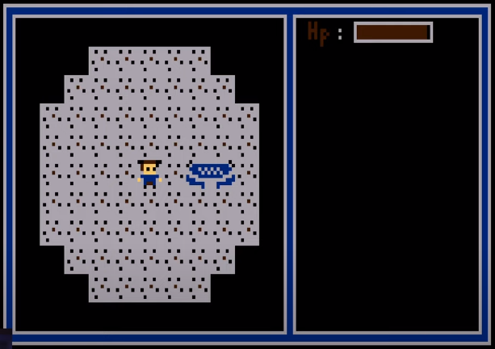

Complete Dashboard

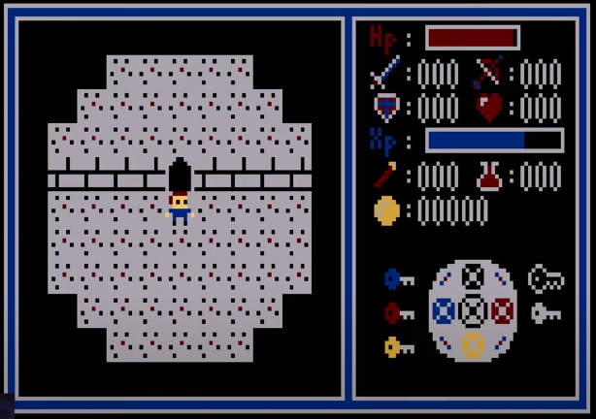

Procedural Map Generation

* Generates the map via procedure code, so we dont have to manually lay out the map one room at a time
* Each floor to have 8 rooms. Doors allow you to move from room to room. Floors are connected by Up and Down ladders. 5 Floors in a Level.
* Steps to Procedural Map Gen
  + Add rooms, Generation Seed, Fill the Map with Walls, Number the rooms, Place the Rooms, Add Doors, Place Doors, Place Special Tiles, Create Occupied Rooms Status

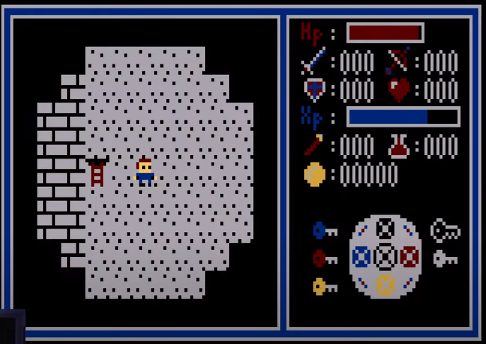 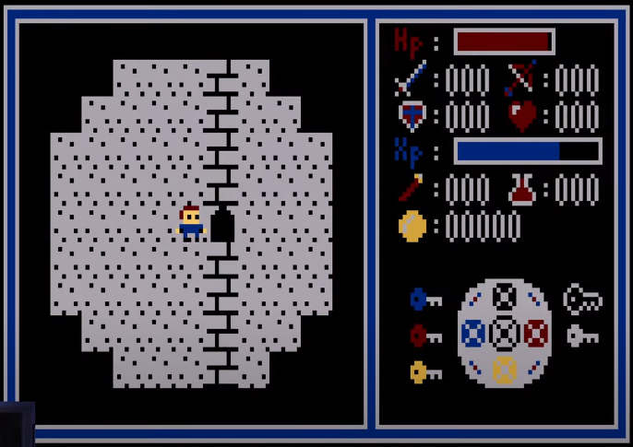

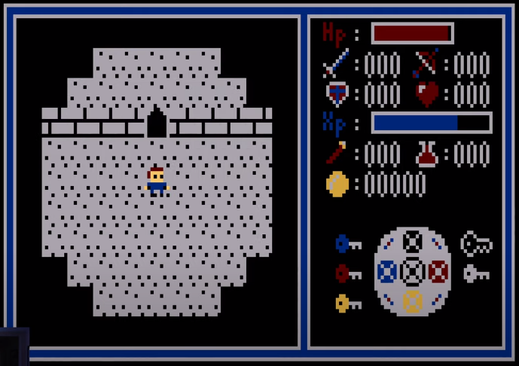 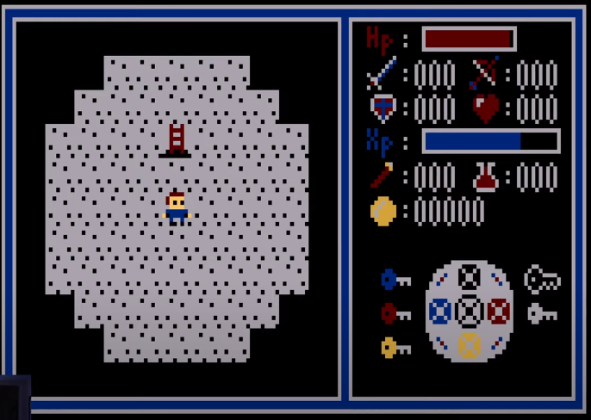

Add Monsters

* Use random number generator to place monsters

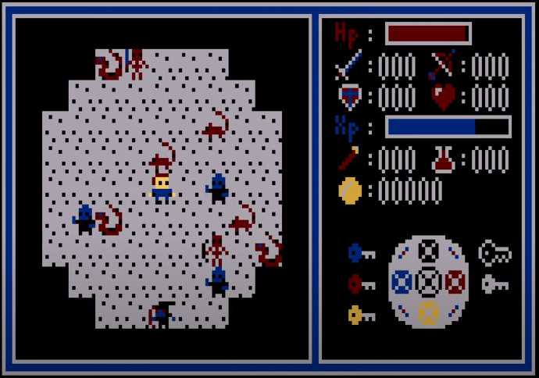

Add Monster Animation

* Compare the two images closely, Left is Monsters A, Right is Monsters B
  + Sward Skeleton - Right Arm Moves up and Down, Sward moves up and down
  + Snake - Tail moves forward and backward
  + Spider - Legs move up and down
  + Vampire - Arms alternate up and down

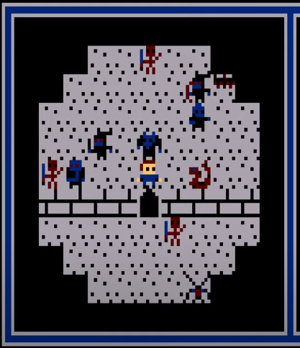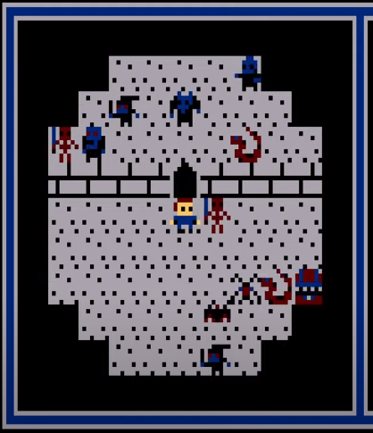

Sward Goblin - Body gets taller and shorter (head moves up and down)

Bow Goblin - Body gets taller and shorter (head moves up and down)

Bat - Wings Flap

Bow Skeleton - Bow Moves Left and Right

Rat - Tail moves left and right

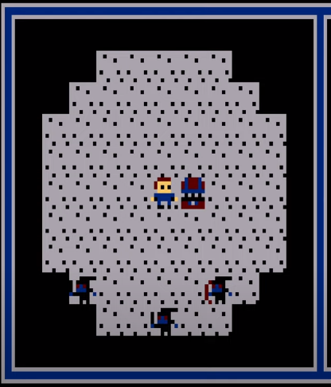 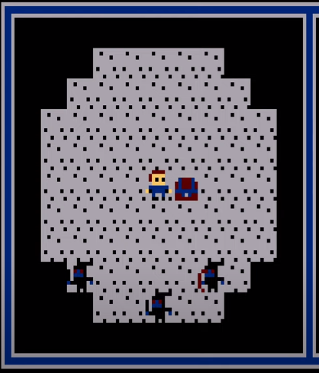

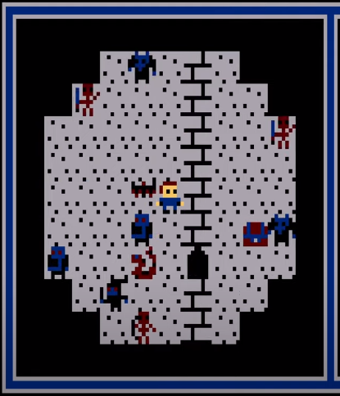 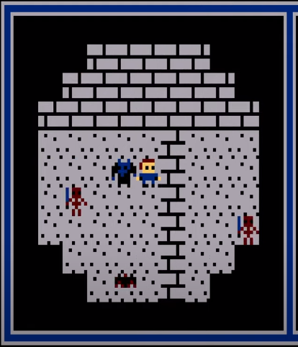

Modify Code so that the Monsters spawn based on Floor Difficulty

* Floor 1 - Snakes and Rats
* Floor 2 - Sward Goblins, Sward Skeletons, and Spiders
* Floor 3 - Bow Goblins and Skeletons
* Floor 4 - Vampires and Bats
* Floor 5 - Dragon in the final Room protecting the Amulet Stone

